# Mini Project Report *on*

Hotel Booking Website - 

# Submitted by

#### Darian Daji(3164018) Exam Seat No.

#### Kedar Ghule(3164036) Exam Seat No.

#### Karan Kajani(3164052) Exam Seat No

#### Advait Khedkar (3164061) Exam Seat No.

##### **Under the Guidance of**

### Faculty Name: Prof. Anjali Shejul and Dr. Pradnya Kulkarni

At



DEPARTMENT OF INFORMATION TECHNOLOGY

MIT College of Engineering

## PUNE – 411038

[October 2018]

Affiliated to



SAVITRIBAI PHULE PUNE UNIVERSITY

Date:

**CERTIFICATE**

This is to certify that,

1. Darian Daji (3164018)
2. Kedar Ghule (3164036)
3. Karan Kajani (3164052)
4. Advait Khedkar (3164061)

of class T.E IT have successfully completed their mini project work on “Hotel Booking System-TRAVOTEL” at MIT College of Engineering, Pune in the partial fulfilment of the Graduate Degree course in T.E at the department of **Information Technology**, in the academic Year 2018-2019 Semester – I as prescribed by the Savitribai Phule Pune University.

Prof. Anjali Shejul Dr. Pradnya Kulkarni Dr. Krishna Warhade

Guide Guide Head of the Department

(Dept. of Information Technology)

**ACKNOWLEDGEMENTS**

We would like to express our deepest appreciation to all those who provided us the possibility to complete this report.  We would like to give special gratitude to our guides, Prof. Anjali Shejul and Dr. Pradnya Kulkarni, whose contribution in stimulating suggestions and encouragement helped us to coordinate this project especially in writing this report and for investing her full effort in guiding our team in achieving the goal.

Furthermore, I would also like to acknowledge with much appreciation the crucial role of the staff of MIT College of Engineering, who gave us the permission to use all required  equipment and laboratories to complete the  our project on Hotel Booking Website- Travotel.

A special thanks goes to our Head of Department and the Principal who gave us the golden opportunity to do this wonderful project which also provoked us in doing a lot of research thereby enabling us to learn so many new things which aided our knowledge and will be of prime importance in the future.

Lastly, we would also like to thank our parents who helped us immensely in finalizing this project within the limited time frame.

Darian Daji (3164018)

Kedar Ghule (3164036)

Karan Kajani (3164052)

Advait Khedkar (3164061)

**Abstract**

The purpose of any hotel booking system is to automate the existing manual system of searching and booking hotel rooms, with the help of computerised equipment and well established computer software, so that a customer does not experience the difficulties associated with the manual operations of the aforementioned task.

Hotel Booking System, as described above, can lead to error free, secure, reliable and fast reservations. It can not only assist the user in the searching and choosing of hotels but also make the process rapid and less erroneous – one need not actually inquire about places to stay, availability of rooms and the quality of service in person.

The project report is a basic manual containing all the information associated with the software developed and the benefits of having such a system in place. It will serve to shed some light on the basics of creating the website and the steps involved in doing the same.

**Table of Contents**

**Title**

**Certificate**

**Acknowledgements**

**Abstract**

1. **Introduction……………………………………………………….. 1**
2. **Scope………………………………………………………………. 3**

2.1 Existing System of Hotel Booking…………………………… **3**

2.2 Scope of Future Application…………………………………. **4**

1. **Software/Hardware Requirement Specification………………... 5**

3.1 Introduction…………………………………………………….. **5**

3.2 Software Requirements………………………………………… **6**

3.3 Hardware Requirements………………………………………. **6**

1. **Entity Relationship Diagram……………………………………. 7**
2. **Relational Database Design……………………………………… 8**
3. **Data Normalization……………………………………………….. 11**
4. **Graphical User Interface..……………………………………….. 14**
5. **Testing: Data Validation………………………………………….. 20**
6. **Conclusion…..…………………………………………………….. 23**
7. **References………………………………………………………….. 24**

**Introduction**

Booking a hotel room is a fundamental task for anyone looking to travel to a land unknown. ‘Travotel’, an Online Hotel Booking website, was borne of a need to ease the process of searching and booking hotels. An otherwise relatively hectic task, booking a hotel room often involves the need to employ a middle man, which invariably incurs more expenses.

The pace of the modern world has led to most manual systems getting replaced by internet based systems. From paying bills to ordering clothes – there are no queues to stand in – everything is at the click of a button. In keeping with the current trend, ‘Travotel’ was designed to connect the user with hotels in a probable destination. The user simply has to make a choice from the options available, confirm his choice and later if he changes his mind, it is just as easy to cancel the reservation.

The purpose of any software is to reduce and in some cases eliminate the hardships faced by a customer in the manual systems. The application in question is optimised to avoid errors while entering the data. For this, invalid data is either completely blocked from entry or prompts an error from the system. All this ensures that a customer does not need to have any technical or programming knowledge to use this website – an idea that was kept in mind while designing this website and measures were taken to serve this very purpose.

Having understood the concepts of Human-Computer Interaction, ‘Travotel’ was built with an attractive GUI to aid the handling of this web-based platform. It is thus, a user-friendly website catering to the needs of people coming from varied backgrounds and differing in technical levels of knowledge. Flow of control in this website is relatively straightforward requiring minimal, and only essential, input from the user.

The first webpage is a standard login page, asking for the user credentials. If the user has already been registered previously, he/she needs to simply enter those credentials, which are then referenced in the database. If the credentials match, the user is logged in and taken to the homepage. Following the input of a specific username and password, the login page could also be redirected to the administrator side of the website. In case of a new user, registration is carried out before logging in, all of which requires specific data and has essential checks all in place, to ensure the data entered is valid.

The homepage, may be used to browse through our featured destinations, enter a city of choice or simply keep tabs on your past visits. The MyAccount tab displays the logged in user’s details and entries of past trips. If any cancellations need be done, the user must pass through this page following which a list of all cancellable reservations are displayed. Returning to the homepage, the user may simply click on a featured image or type a city’s name in the search-box.

A search results in displaying a list of all hotels on the matched city name - fetched from the database. Hotels are displayed with an image and a brief description. Clicking on one redirects you to the reservation page, where a more detailed description of the hotel along with inputs for the reservation details like dates and duration, type of hotel room and its price – all fetched from references to the database with specific matches.

Having entered the details, basic checks are carried out to ensure no trivial inputs like having a check-out date prior to the check-in date are accepted in the database. These are ensued by an algorithm designed specifically to see if enough rooms are available for the entire duration of the stay, satisfying which either the user is asked to proceed for payment to confirm his reservation or the respective error message is generated.

Payment confirms the reservation - similar checks are carried out to ensure credentials here are valid as well. Amount and other details of the reservation are displayed and are now visible in the MyAccount page as well. The user is free to carry on browsing through the website as desired.

All the above stated activities are essentially controlled by the administrator side which performs all the backend tasks of adding or removing a hotel, or a room type in a particular hotel, or updating its price in the future. The administrator can also see all the reservations that have been made in the current month. This gives almost unprecedented control over all that is displayed on the website.

In this document, the architecture, working, flow and steps involved in the development of the website have been discussed. Future possible ventures are also mentioned in brief as are the hardware and software requirements. Test cases to show the reliability of validation checks are also added. The aim is ultimately to provide a better understanding of the website, its working and implementation.

**Scope**

## Existing System of Hotel Booking System:

* + The scope generated is intended for the reservations of rooms at a hotel of the user’s choice in any desired location. This process will be carried out by the software produced.
  + The primary end user is the customer who intends to book a room. The user will have to choose a location in terms of city name. Once decided, a hotel must be picked. Further, the customer will be able to check the various rooms and their associated prices. The user will then select the room and proceed to confirm the booking and payment.
  + The secondary user is the system administrator - with the privilege to add or remove a hotel from the database. An administrator possesses the rights to modify a hotel’s details at will.
  + The main goal of this project is to facilitate easy searching and booking of a place to stay when on a trip or excursion, for a customer, through the means of an online application. This website will prove to be very relevant in the present scenario where choice of hotels is almost endless and the automation of the process for searching and booking is necessary.
  + The system provides proper security and reduces the manual work.
* Security of data.
* Ensures data accuracy.
* Proper control of the higher officials.
* Minimize manual data entry.
* Greater efficiency.
* Better service.
* User friendliness and interactive.

**Scope of Future Application**

This project is highly relevant in the context of the real world, where millions of hotels are booked on a daily basis and is a few modules and safety features away from being implemented in a global scope. Utmost care and back-up procedures must be established to ensure 100% successful implementation of the computerized hotel system. In case of system failure, the organization should be in a position to process the transaction with another organization or if the worst were to arise, it should be in a position to complete the task manually.

**Software/Hardware Requirements Specification**

**Introduction**

‘Travotel’ is a website for booking a hotel room or several rooms, as the need may be, through means of an online application. The customer can search for hotels by entering the location of his desired visit, followed by selecting a hotel of choice and confirming the other details relevant to the confirmation of reservation.

**Purpose:**

* S.R.S. provides the information about the software used, minimum hardware required, etc.
* The main objective is to provide a base for the foundation of the project. It gives a comprehensive view of how the system is supposed to work.
* It provides a better understanding of the project, which will be useful for development and also future stages.
* It provides a blueprint of the project, which may be useful for modifications and maintenance.

**Product Functions:**

The website is supposed to perform the following functions

* Customer log-in.
* Customer sign-up.
* Hotel search by entering location in terms of city name.
* Providing list of available hotels according to the search string.
* Displaying the details of a particular hotel.
* Displaying the types of rooms available and their prices.
* Booking and reservation system.
* Payment interface.
* Cancelling a confirmed reservation.
* Maintaining account details for registered users.
* Maintaining record of reservations and payments.

**Software Requirements:**

1. **User :**

User interface, i.e. the website itself, will be compatible to any type of browser such as Mozilla Firefox, Google Chrome, and Internet Explorer (ver8+).

1. **Developer :**
   * Web Server-

Apache Tomcat Server (XAMPP)

O.S. (Windows, Linux, etc.)

* Database Server-

MySQL database

* + - Development End-

PHP, PHPMyadmin, HTML, C.S.S., JavaScript

* Text editor

Notepad, Notepad++, Sublime, etc.

**Hardware Requirements:**

1. R.A.M.

Minimum 1GB or higher.

1. Processor

Intel, or AMD.

1. Internet Connection

L.A.N., Broadband, Wi-Fi, etc.

**Entity Relationship Diagram**

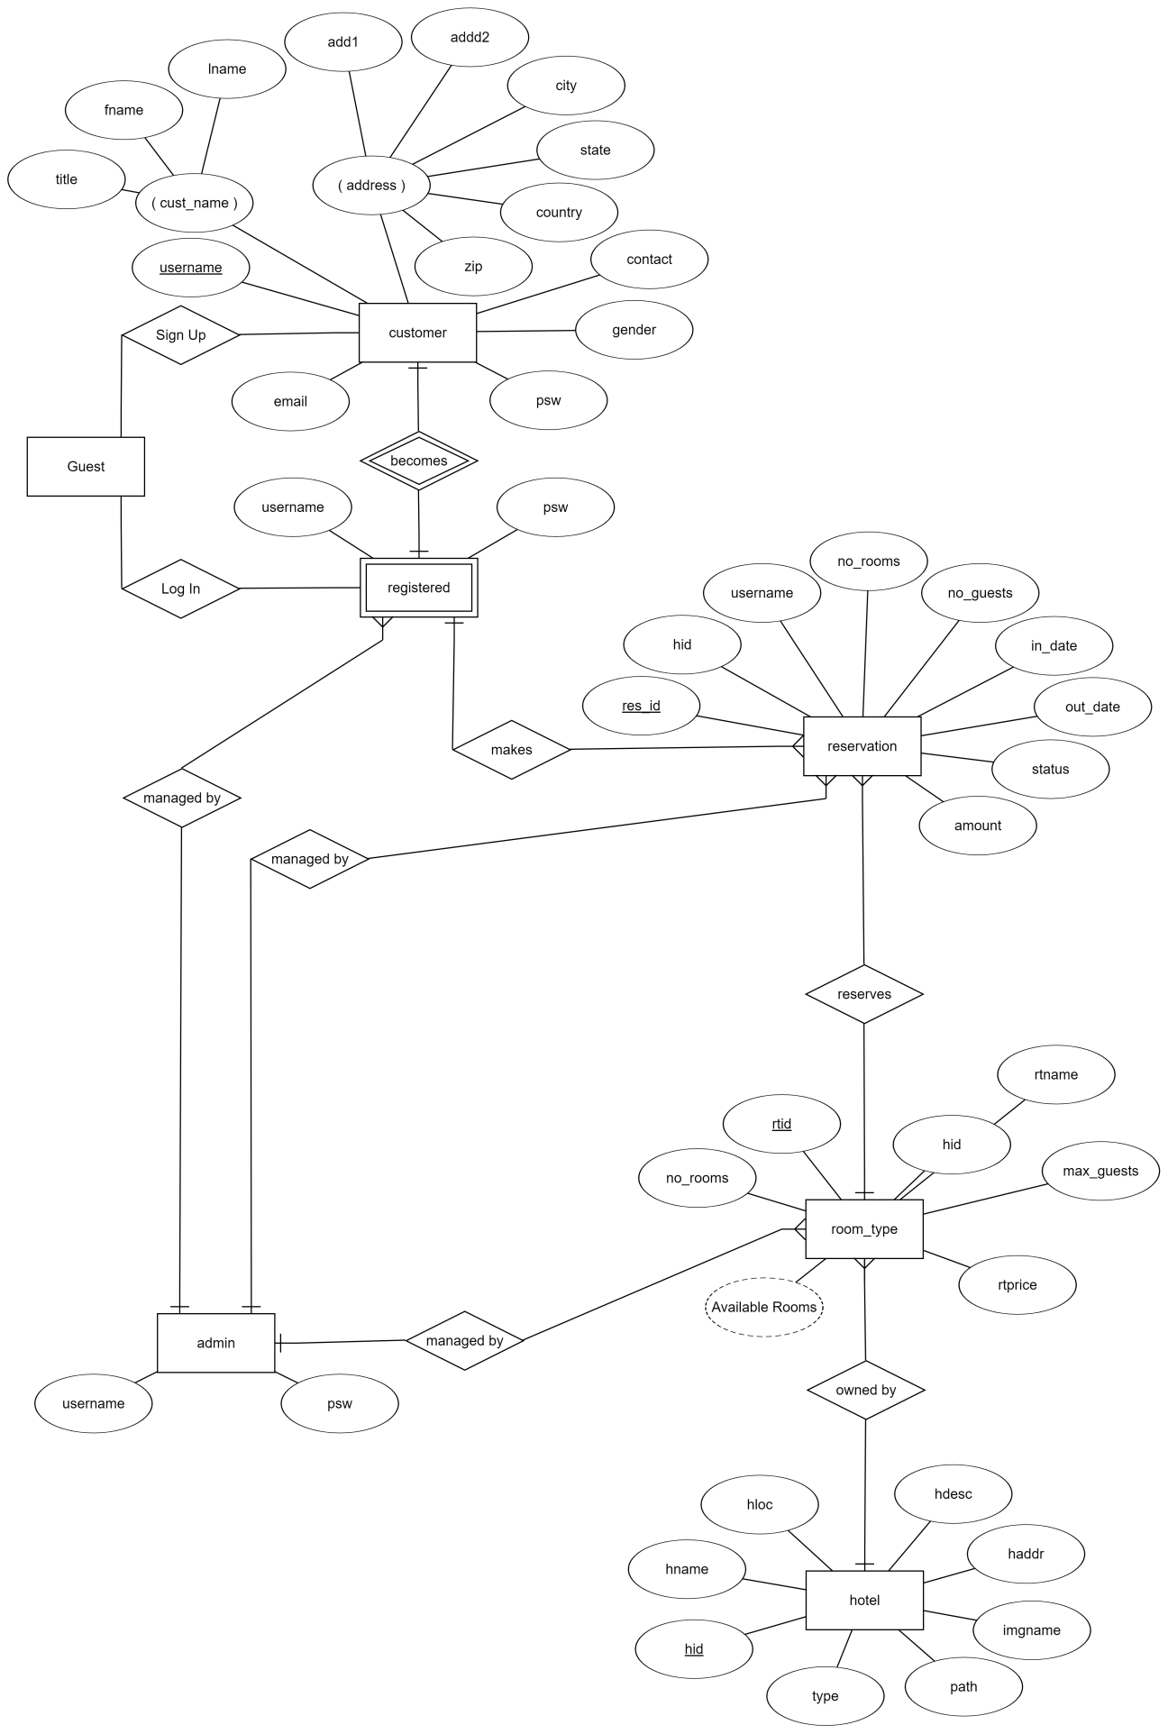

**Relational Database Design**

Relational database design (RDD) models information and data into a set of tables with rows and columns. Each row of a relation/table represents a record, and each column represents an attribute of data. The Structured Query Language (SQL) is used to manipulate relational databases. The design of a relational database is composed of four stages, where the data are modelled into a set of related tables. The stages are:

1. Define relations/attributes 2. Define primary keys

3. Define relationships 4. Normalization

## Database Schema

A database schema is the skeleton structure that represents the logical view of the entire database. It defines how the data is organized and how the relations among them are associated. It formulates all the constraints that are to be applied on the data.

A database schema defines its entities and the relationship among them. It contains a descriptive detail of the database, which can be depicted by means of schema diagrams. It is the database designers who design the schema to help programmers understand the database and make it useful.

A database schema can be divided broadly into two categories −

* Physical Database Schema

This schema pertains to the actual storage of data and its form of storage like files, indices, etc. It defines how the data will be stored in a secondary storage.

* Logical Database Schema

This schema defines all the logical constraints that need to be applied on the data stored. It defines tables, views, and integrity constraints.

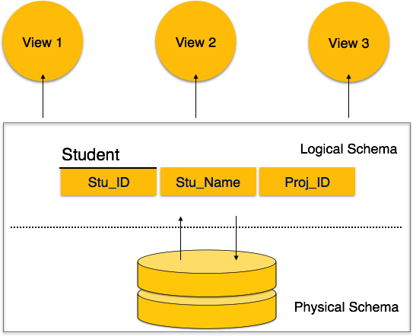

Figure 1:- Database Schema (Reference no 2)

The logical schema of our database, is shown hereby:-

1. Customer (username, psw, title, fname, lname, add1, add2, city, state, country, zip, contact, gender, email)
2. Registered (username, psw)
3. Reservation (res_id, no_of_rooms, no_of_guests, in_date, out_date, amount, status, username, hid)
4. Room_type (rtid, rtname, max_guests, rtprice, no_of_rooms, hid)
5. Hotel (hid, hname, hloc, hdesc, haddr, imgname, path, type)

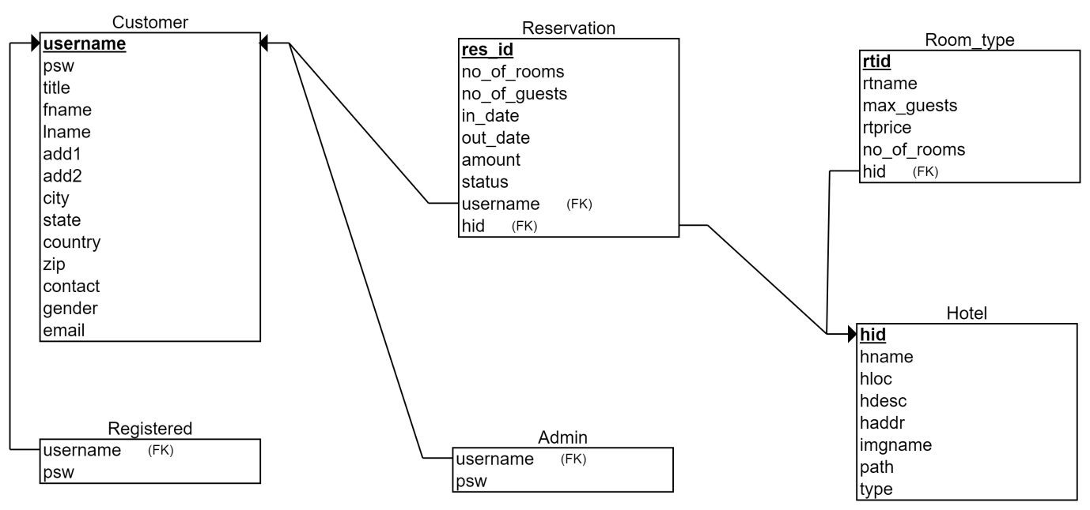

Figure 2:- Schema diagram

The database has 6 tables. Their purpose is given as follows:

1. Customer:
   * Stores the customer information on sign-up.
   * Used by the Registered, Reservation and Admin tables.
2. Registered:

* Maintains the username and password of registered customers.
* Useful for identifying if customer is registered or not.

1. Admin:

* Stores the username and password of admin accounts separately.
* Useful for deciding which user is allowed to access the admin page.

1. Reservation:

* Saves all the information about every reservation that any customer makes.
* This table will also handle cancellations.

1. Room_type:

* Stores the information about rooms - their types, max no of guests of every type, and so on.

1. Hotel:

* Maintains the list of hotels, and the information of each.

**Normalization**

It is the process of minimizing redundancy from a relation or set of relations. Redundancy in relation may cause insertion, deletion and update-related anomalies. Normal forms are used to eliminate or reduce this redundancy in database tables thereby making the database free from erroneous operations.

### First Normal Form – If a relation contains composite or multi-valued attributes, it violates first normal form; or, a relation is in first normal form if it does not contain any composite or multi-valued attribute. A relation is in first normal form if every attribute in that relation is singled valued attribute.

### Second Normal Form –To be in second normal form, a relation must be in first normal form and relation must not contain any partial dependency. A relation is in 2NF if it has n**o partial dependency,**i.e.**,**no non-prime attribute (attributes which are not part of any candidate key) is dependent on any proper subset of any candidate key of the table.

**Partial Dependency –** If proper subset of candidate key determines non-prime attribute, it is called partial dependency.

### Third Normal Form – A relation is in third normal form, if there is no transitive dependency for non-prime attributes is it is in second normal form. A relation is in 3NF if **at least one of the following condition holds** in every non-trivial function dependency X –> Y

* 1. X is a super key.
  2. Y is a prime attribute (each element of Y is part of some candidate key).

**Transitive dependency –**If A->B and B->C are two FDs then A->C is called transitive dependency.

**Normalization in Used Tables**

1. **Customer**

|  |  |  |  |  |  |  |  |  |  |
| --- | --- | --- | --- | --- | --- | --- | --- | --- | --- |
| username | psw | Name | Add | State | Country | Zip | No. | Gender | email |
|  |  |  |  |  |  |  |  |  |  |

1. **Registered**

|  |  |
| --- | --- |
| Username | psw |
|  |  |

1. **Admin**

|  |  |
| --- | --- |
| Username | psw |
|  |  |

1. **Reservation**

|  |  |  |  |  |  |  |  |  |  |  |  |  |
| --- | --- | --- | --- | --- | --- | --- | --- | --- | --- | --- | --- | --- |
| Res_id | No_of  _rooms | No_of  _guests | In_  Date | Out_  date | Amount | Status | Username | hid | Hname | Hloc | Haddr | Hdesc |
|  |  |  |  |  |  |  |  |  |  |  |  |  |

1. **Hotel**

|  |  |  |  |  |  |  |  |
| --- | --- | --- | --- | --- | --- | --- | --- |
| hid | hname | hloc | hdesc | haddr | imgname | path | type |
|  |  |  |  |  |  |  |  |

1. **Room_type**

|  |  |  |  |  |  |
| --- | --- | --- | --- | --- | --- |
| Rtid | Rtname | Max_guests | Rtprice | No_of_rooms | hid |
|  |  |  |  |  |  |

**First Normal Form**

As we have not used any multi valued attributes in our tables, the tables are in First Normal Form**.** Therefore, no further steps need to be carried out to bring any of these tables into 1NF.

**Second Normal Form**

There is no composite key in any of the tables. A single primary key is present and all the attributes are solely dependent on the respective primary key. Thus, the tables appear to be in Second Normal Form. Again, no further steps are required to bring any of the described tables into 2NF.

**Third Normal Form**

A relation is said to be in third normal form if it is already in 1NF and 2NF, and has no transitive dependency.

There is a clear transitive dependency in the ‘Reservation’ table with hotel details dependent on ‘hid’ and ‘hid’ in turn, dependent on ‘res_id’. Thus, ‘Reservation’ table is not in Third Normal Form. To resolve this issue, we split the ‘Reservation’ table into two tables – ‘Reservation’ and ‘Hotel’. As ‘Hotel’ table is already present along with all the attributes needed by ‘Reservation’ table, there is no need for creation of a new table, just splitting and linking of the two tables is carried out.

1. **Reservation**

|  |  |  |  |  |  |  |  |  |
| --- | --- | --- | --- | --- | --- | --- | --- | --- |
| Res_id | No_of_Rooms | No_of_Guests | In_date | Out_date | Amount | Status | Username | hid |
|  |  |  |  |  |  |  |  |  |

1. **Hotel**

|  |  |  |  |  |  |  |  |
| --- | --- | --- | --- | --- | --- | --- | --- |
| Hid | Hname | Hloc | Hdesc | Haddr | Imgname | Path | type |
|  |  |  |  |  |  |  |  |

Now all the tables appear to be in 3NF. It may be stated here that all the tables used for creating the database are at least in Third Normal Form.

*As normalization reduces redundancy and data loss, a project should be at least in 3NF to ensure quality of software.

**Graphical User Interface**

Customer Registration Page –

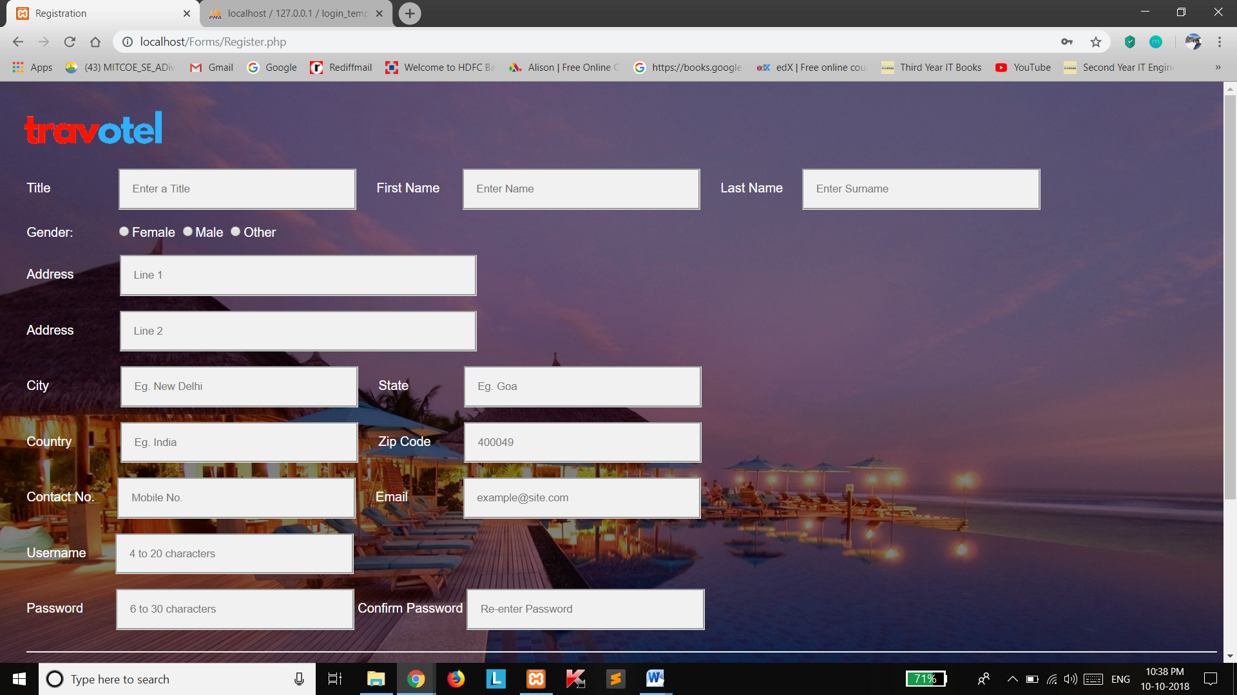

Login Page –

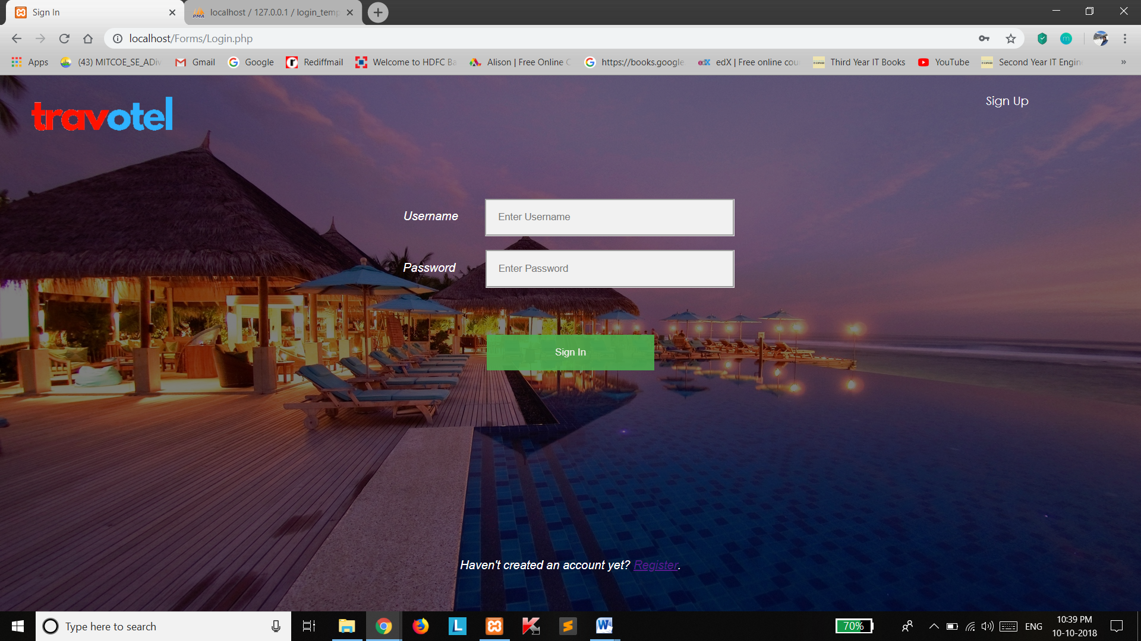

Customer Home Page –

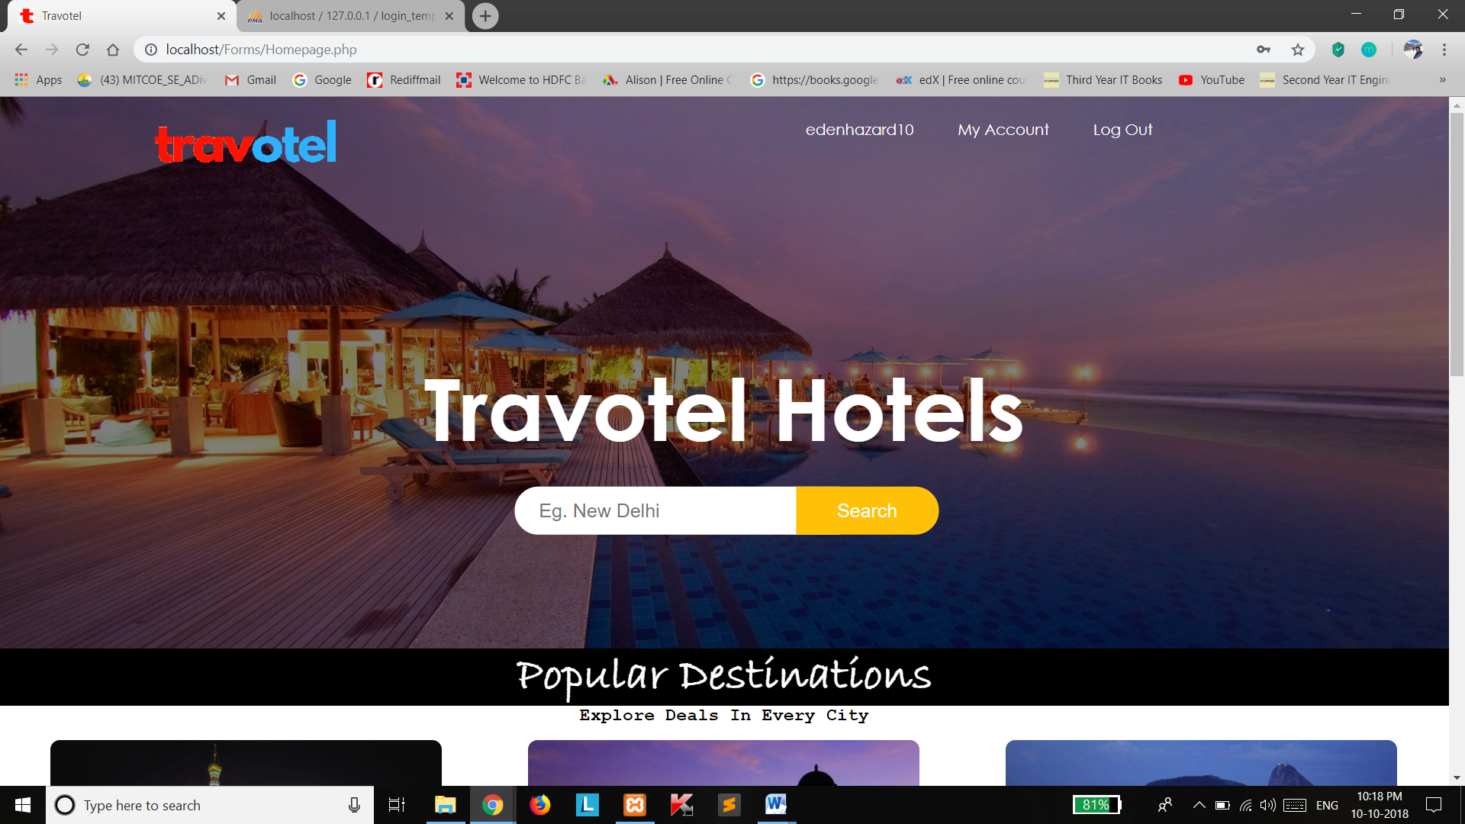

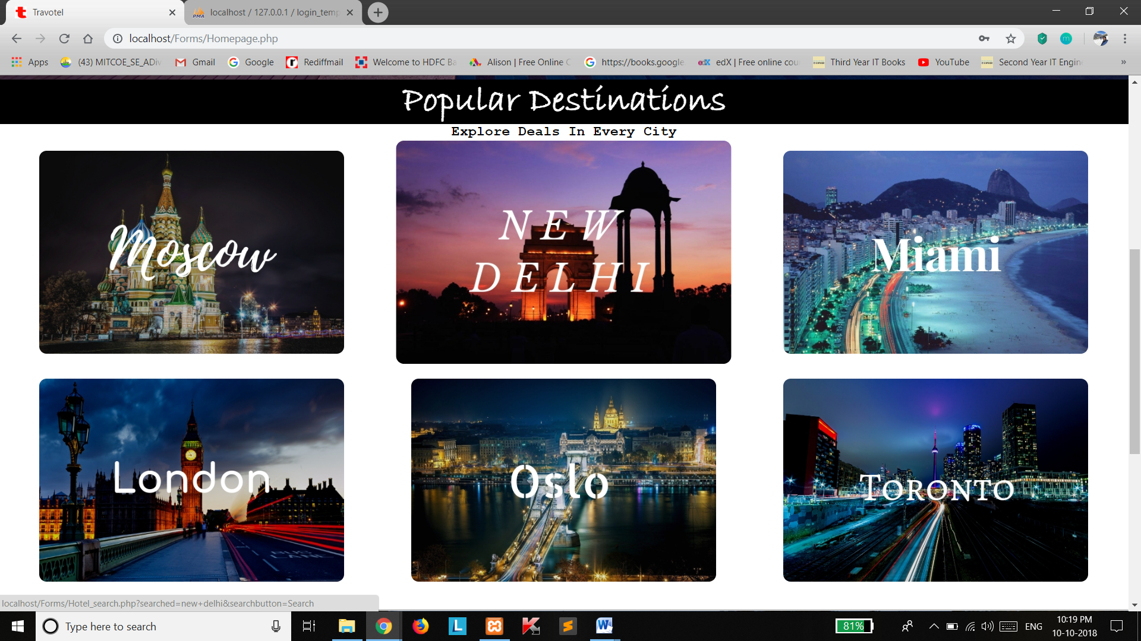

Hotel Search Page –

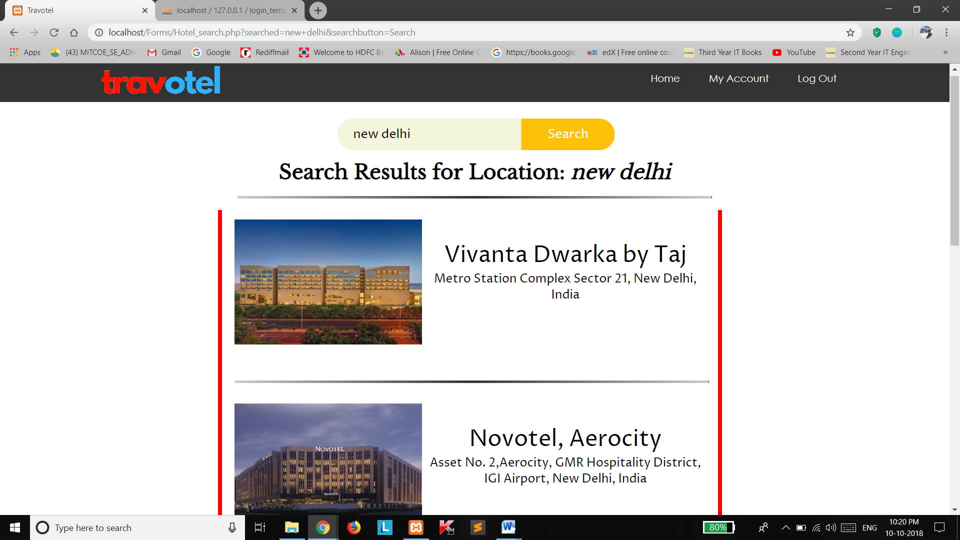

Reservation Page –

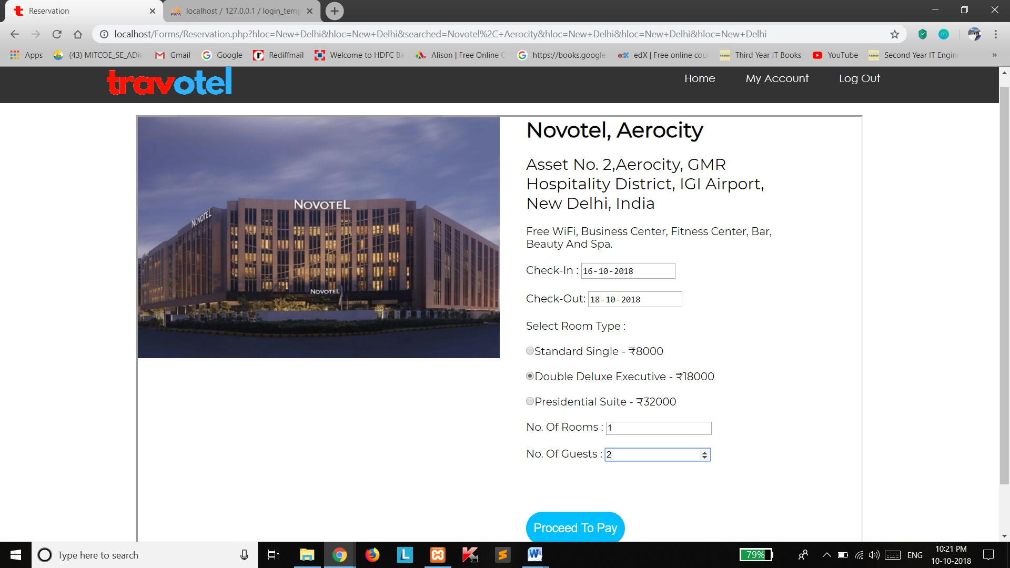

Payment Page –

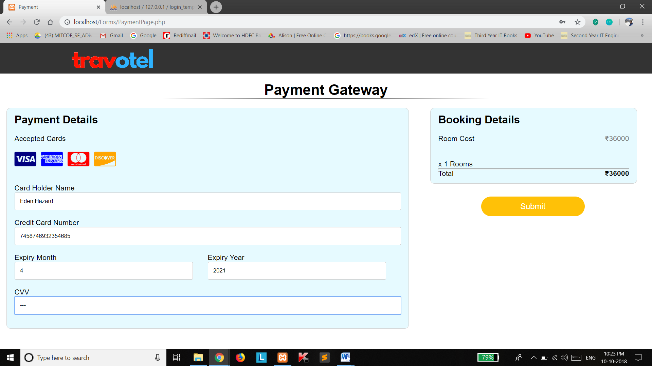

Payment Confirmation –

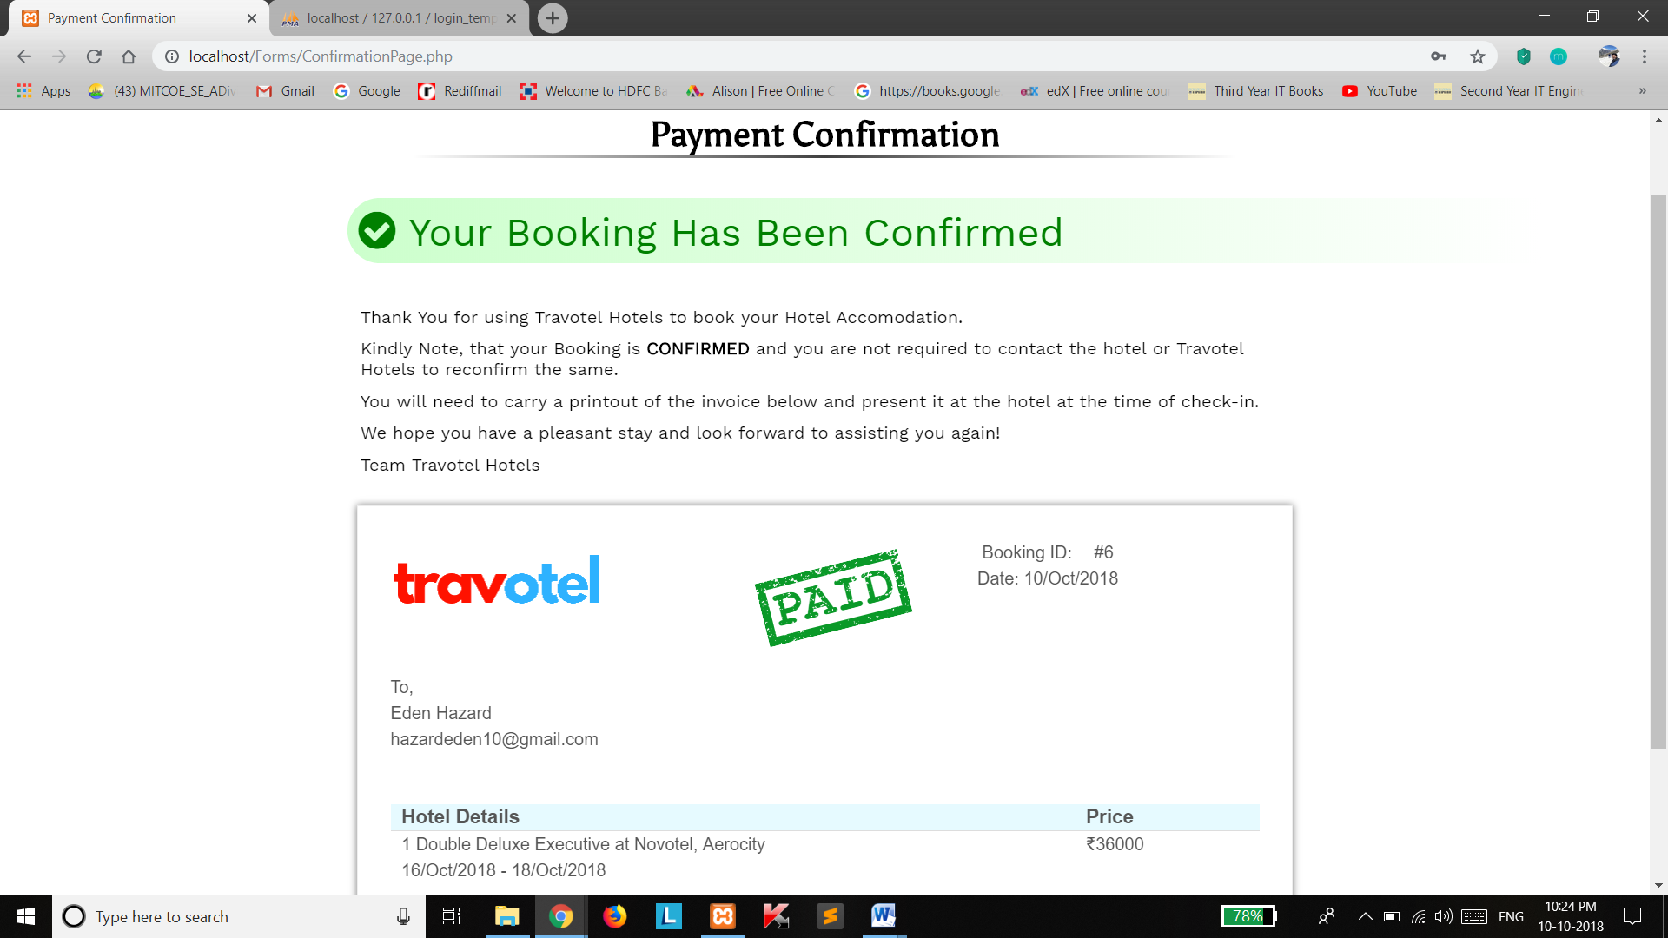

My Accounts Page –

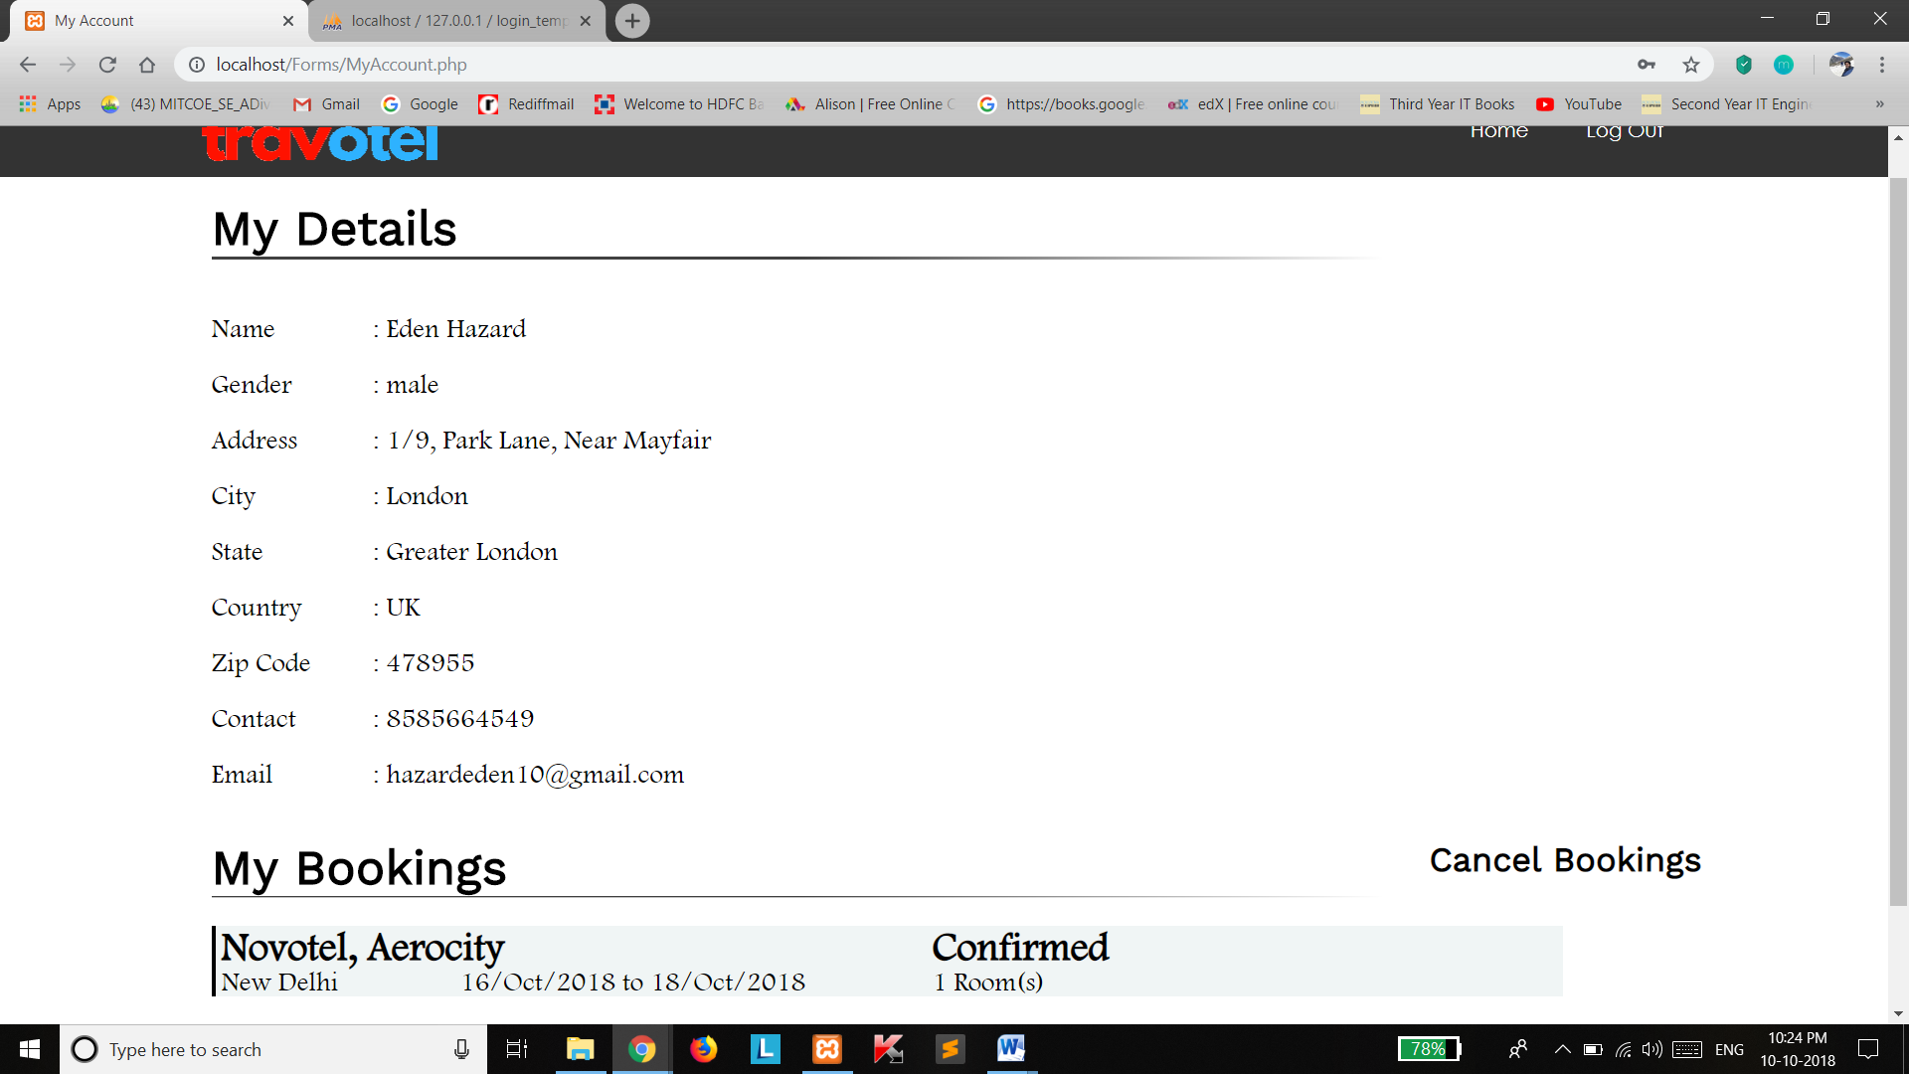

Cancel Bookings Page –

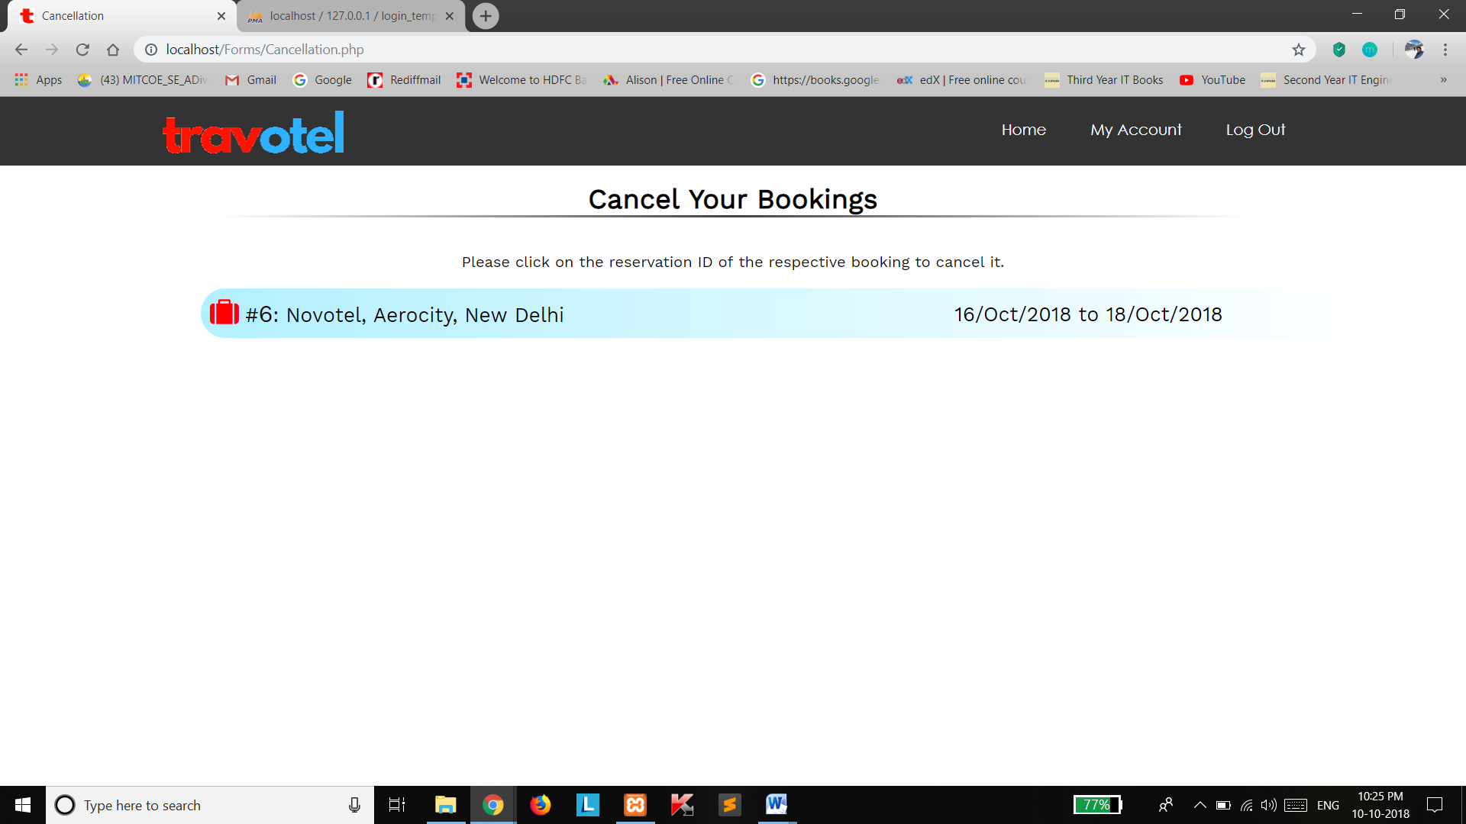

Admin Home Page –

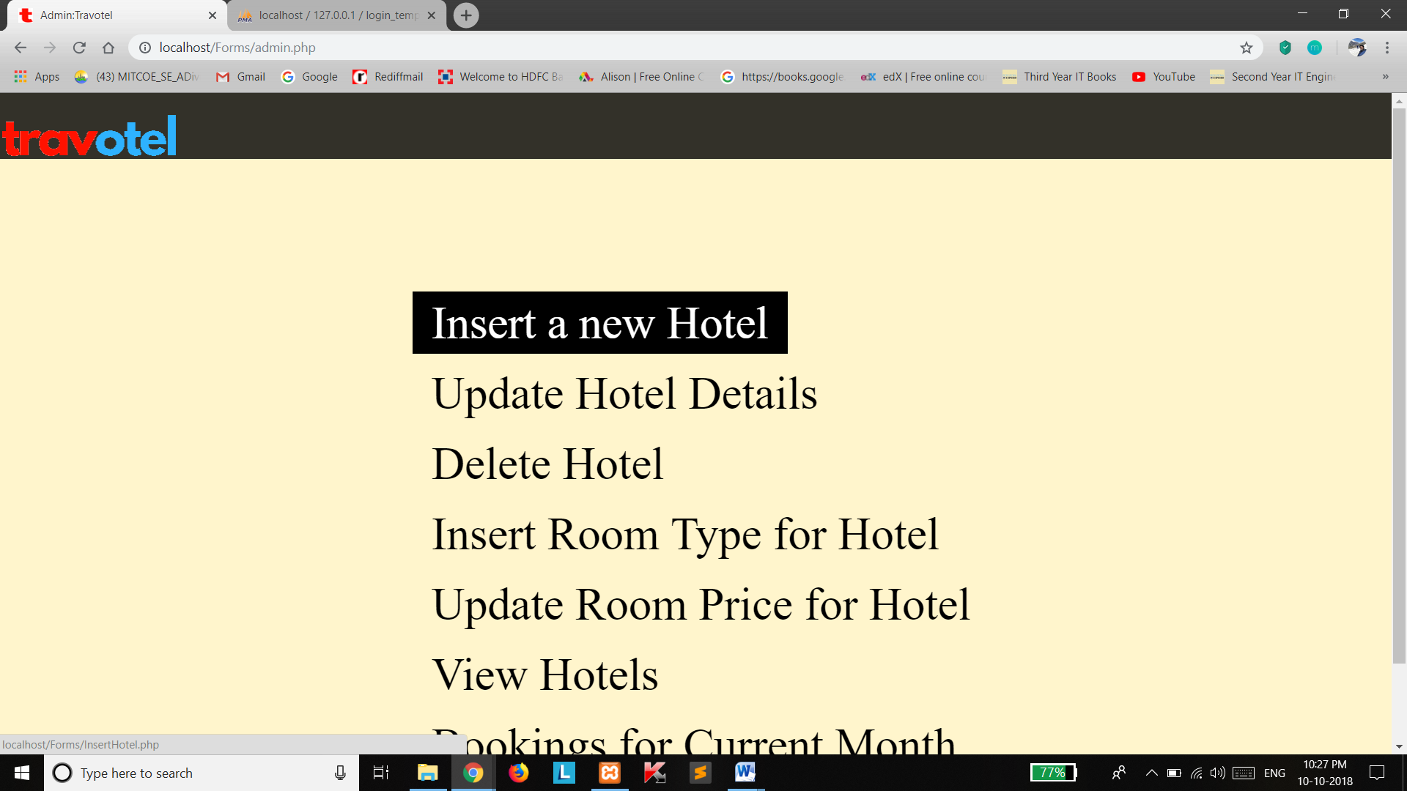

Insert Hotel Page –

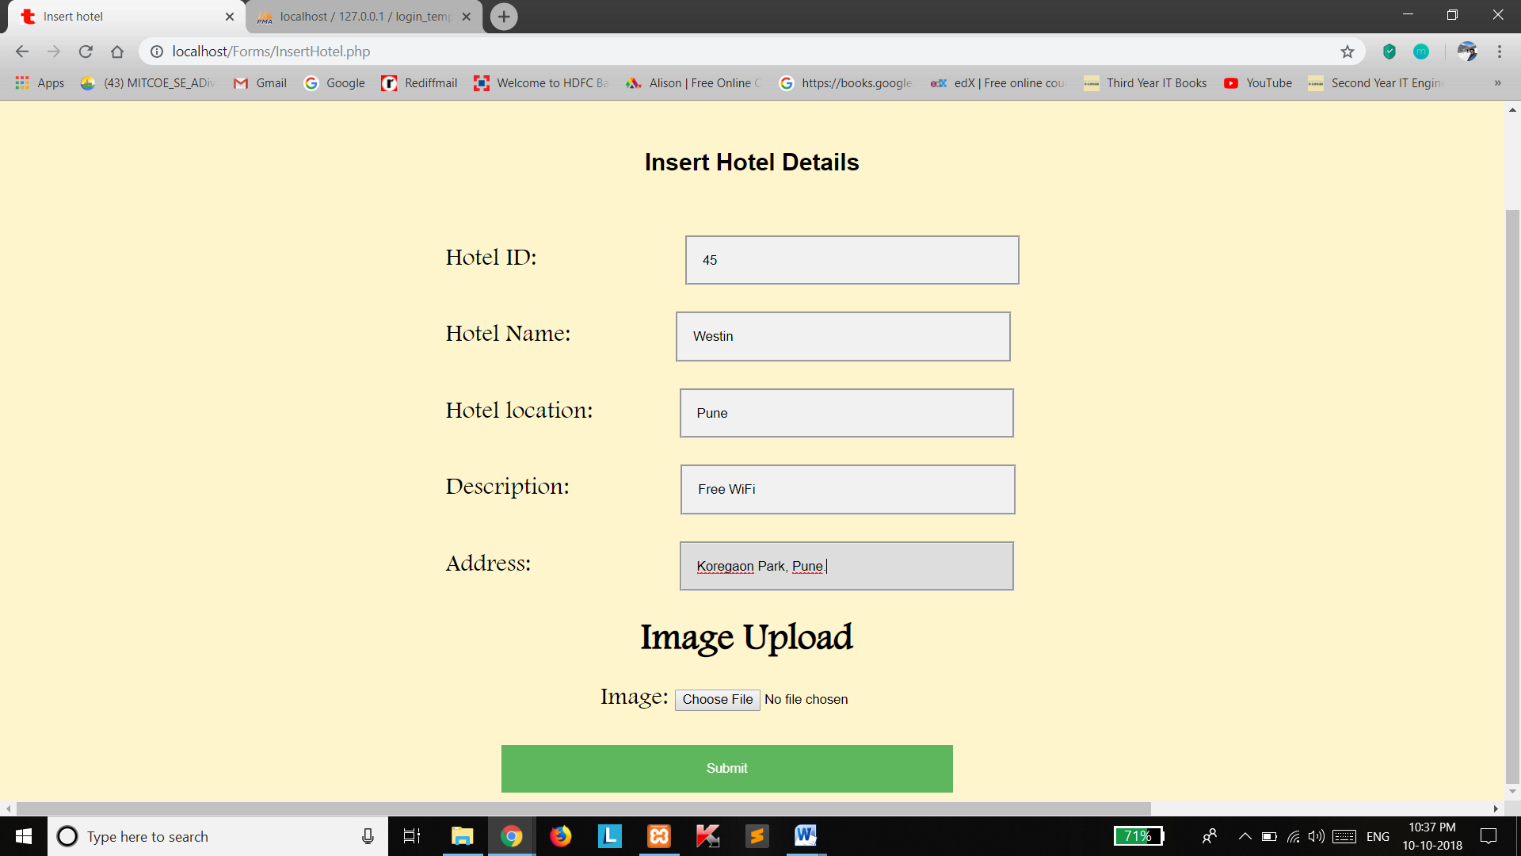

**Testing : Data Validation**

* Log-In Page Validation –

If username does not match to that of any registered customer or admin.

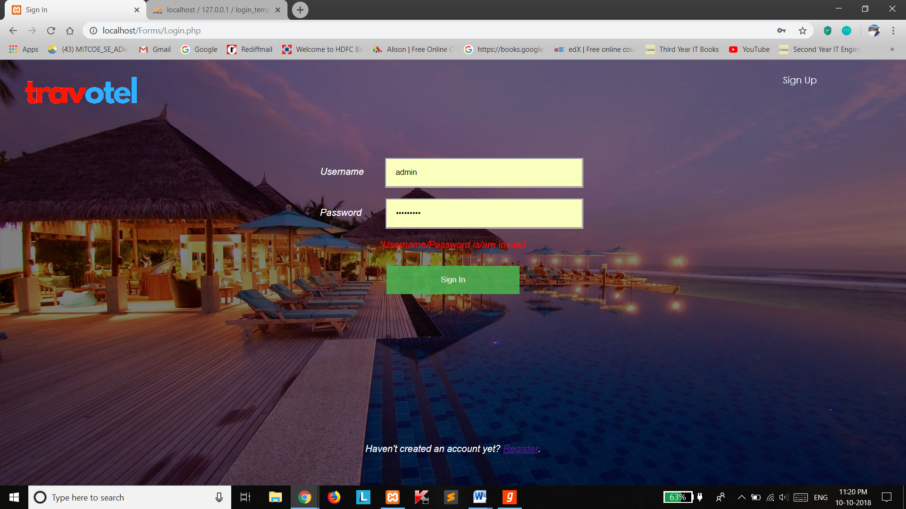

* Registration Page Validation –

Validations present are for Name, City, State, Country (should include only alphabets), Mobile Number (should be of 10 digits), Email, Username (should be between 4 to 20 characters), Password (should be between 6 to 30 characters) and for all the required fields.

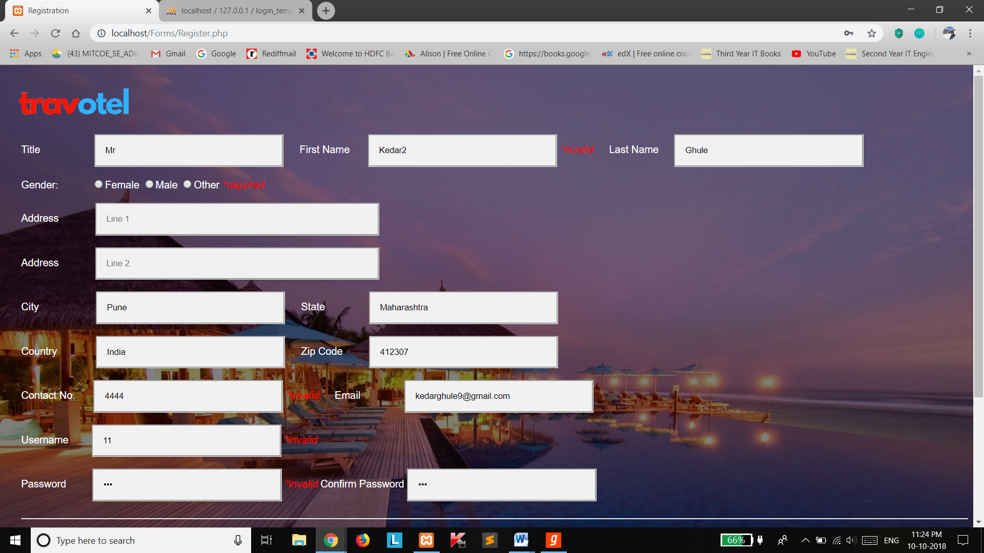

* Hotel Search Page Validation –

If a location name not present in the database has been entered.

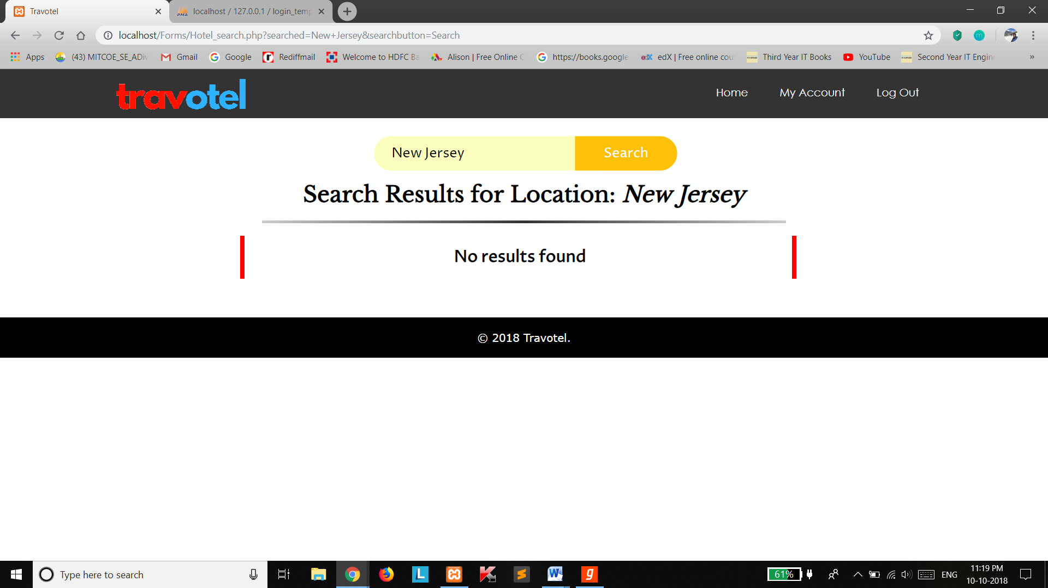

* Reservation Page Validation –
  + 1. If Check-out Date is lower than Check-In date, an appropriate message is displayed.
    2. If no. of guests do not fit in the no. of rooms entered by the user.

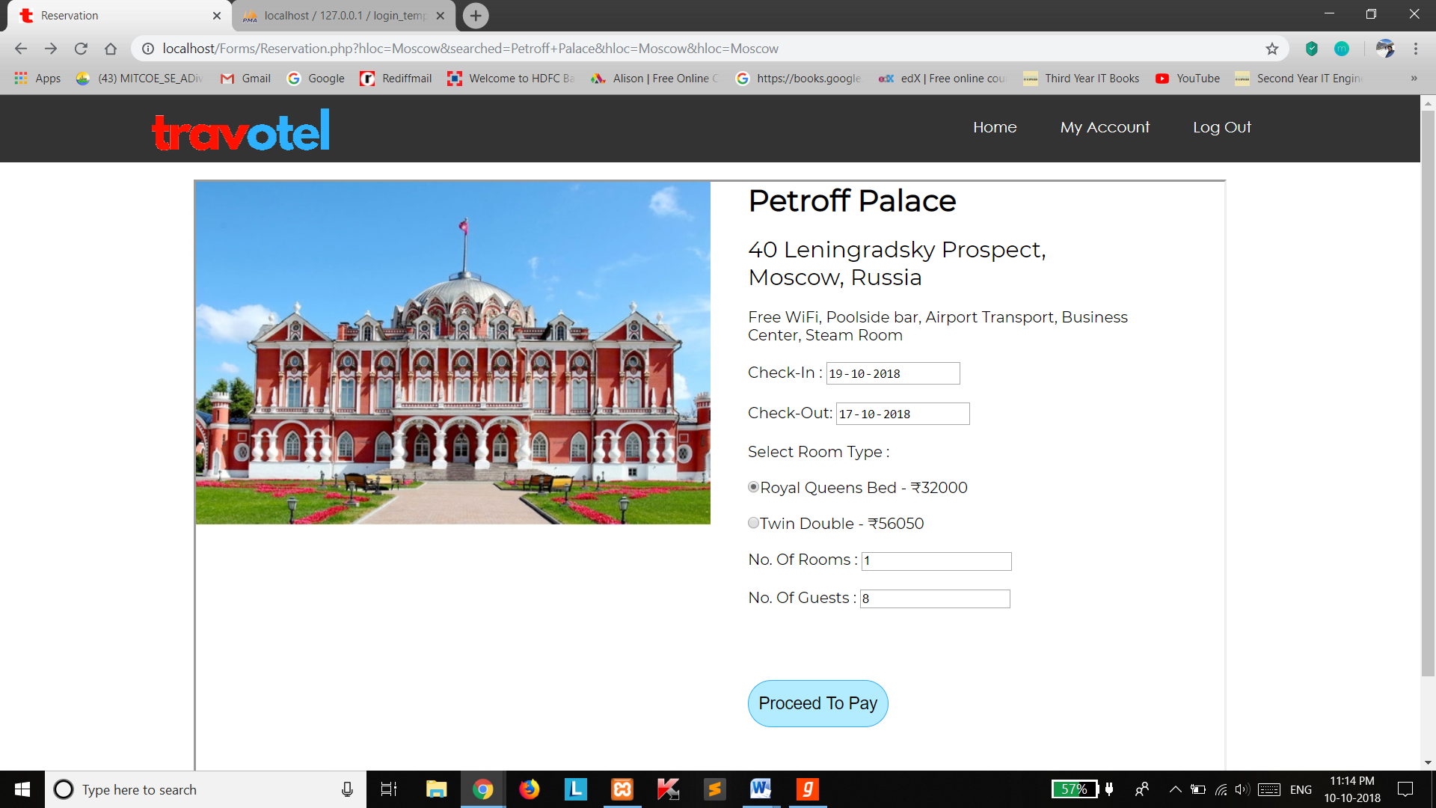

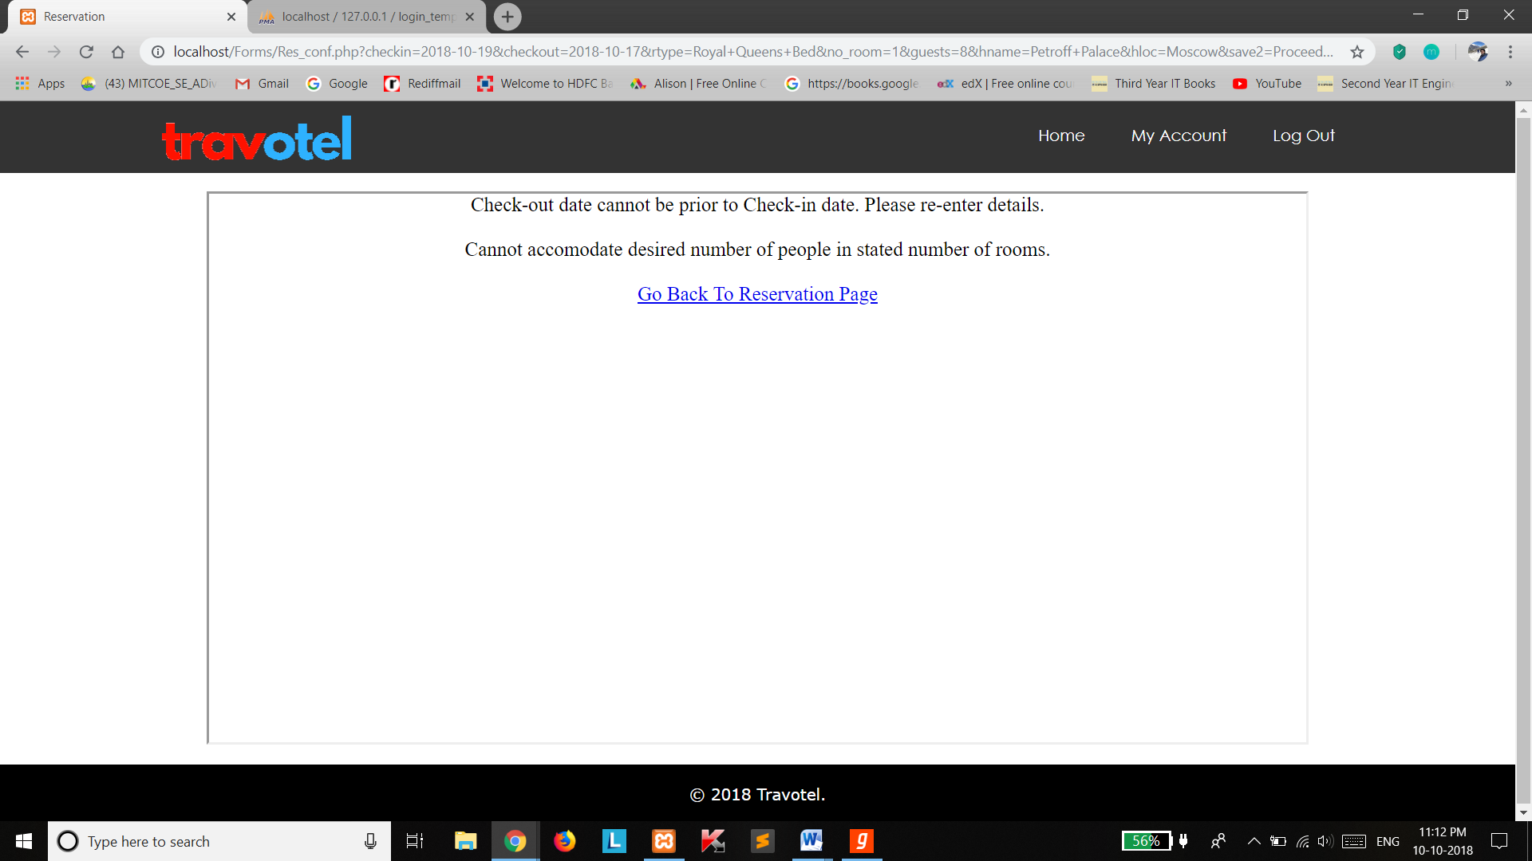

* Payment Page Validation –

Validations include for Name (only alphabets), 16 digit credit card number, 3 digit CVV number, month and year validations.

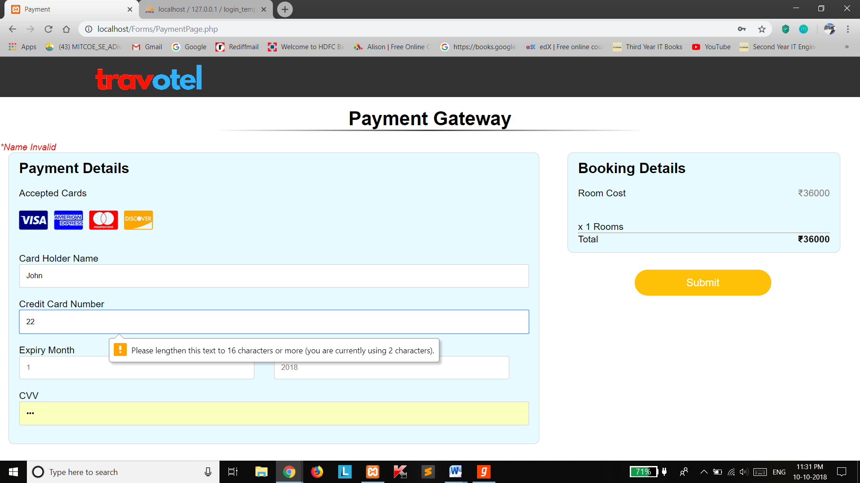

**Conclusion**

The objective of software planning is to provide a frame work that enables the manager to make reasonable estimates within a limited time frame at the beginning of the software project and should be updated regularly as the project progresses.

This project is only a humble venture to delve into and understand the need to manage project work. User friendly coding ensures that the project is easy to understand and ensuing changes are not cumbersome. This should prove to be a powerful package in satisfying all the requirements of the chosen topic.

The ability to search about specific information or reflect on the recent activity just performed is a critical purpose for building a system in which these requirements can be served in an efficient and timely manner. ‘Travotel’ is built as an answer to these requirements regarding customizations of rooms, guests, payments, administration and services. The data is stored in databases reducing redundancy as far as possible and preventing damage that may occur in traditional file systems. The system deals with all the queries associated with the MySQL server keeping in mind the concepts of Data Abstraction, thus, making the system that is handed to the client a relatively simple one based solely on GUI.

**Overall the project teaches us essential skills like:**

* Using system analysis and design techniques like data flow diagram in designing the system.
* Understanding the database handling and query processing.
* A description of the background and context of the project and its relation to work already done in the area.
* The description of purpose, scope, and applicability.
* Description of requirement specifications of the system and the actions that may be taken on these things.
* Understanding the problem domain and producing a model of the system, which describes operations that can be performed on the system.
* Designed user interface and security issues related to system.

**References**

1. **Entity Relationship Diagram**

https://www.tutorialspoint.com/dbms/er_diagram_representation.htm

1. **Relational database design**

https://www.techopedia.com/definition/25113/relational-database-design-rdd

1. **Graphical User Interface**

https://www.w3schools.com/

1. **Database schemas**

https://www.tutorialspoint.com/dbms/dbms_data_schemas.htm

1. **Yatra.com**

https://www.yatra.com/hotels

1. **MakeMyTrip**

https://www.makemytrip.com/hotels/

1. **MySQL**

http://www.mysqltutorial.org/

1. **PHP and MySQL Web Development Book by Luke Welling**
2. **Guidelines for S.R.S.**

https://www.slideshare.net/ParasPahari/hotel-management-system-srs